**Steps to create the LVM**

**Command to View Luns in**

fdisk -l & lsblk -l

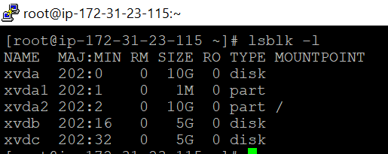

**Create primary partition**

# fdisk /dev/xvdb

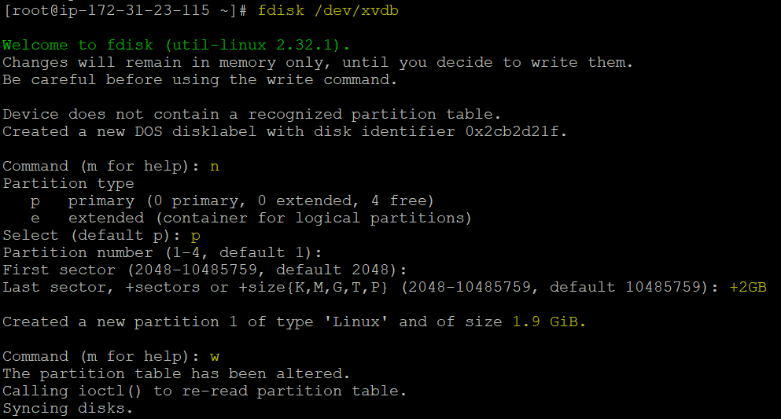

**Verify the partition:**

fdisk -l /dev/xvdb1

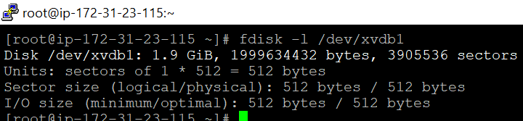

**Create Physical volume:**

# pvcreate /dev/xvdb1

# pvs

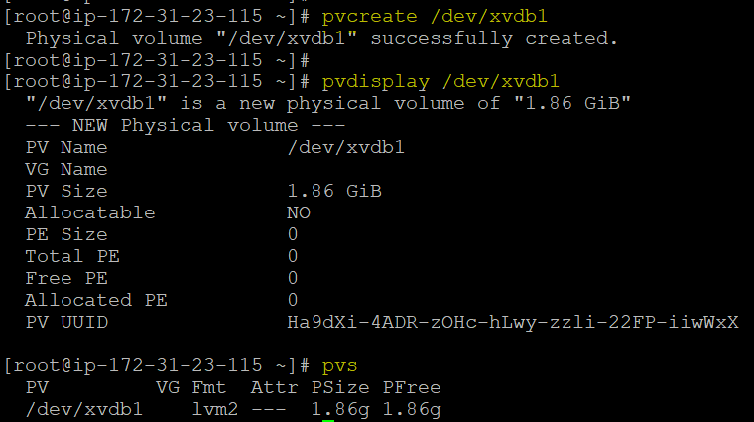

**Create Volume group**

# vgcreate test_vg1 /dev/xvdb1

# vgs

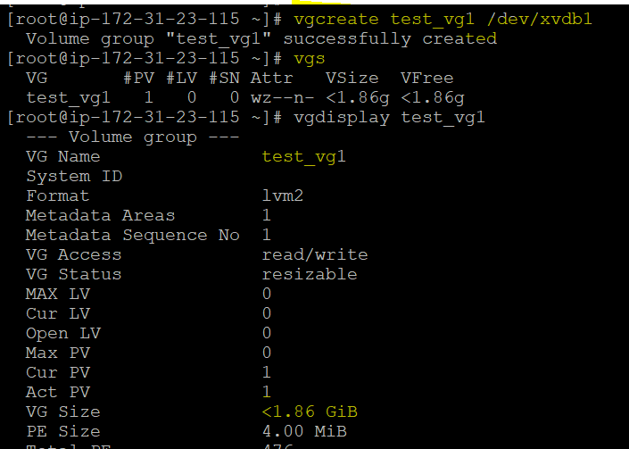

**Create Logical volume:**

# lvcreate -n test-lv --size 1GB test_vg1

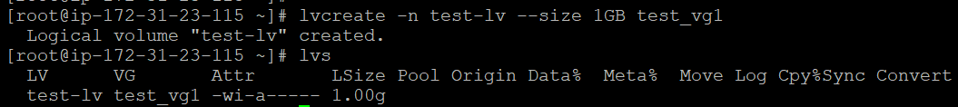

**Convert LV into ext4/xfs filesystem:**

# mkfs.ext4 /dev/test_vg1/test-lv

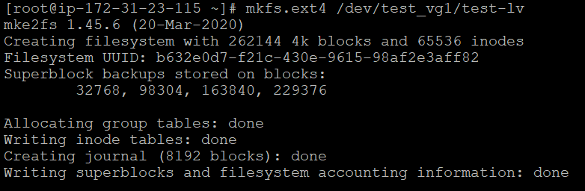

**Mount the file system**

# mkdir /lv-data

# mount /dev/test_vg1/test-lv /lv-data/

# df -h

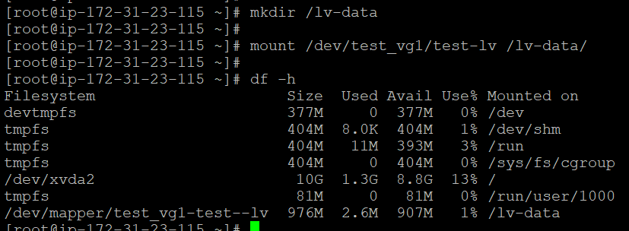

**Extend LV**

lvextend -L +125 /dev/test_vg1/test-lv

resize2fs /dev/test_vg1/test-lv

lvs

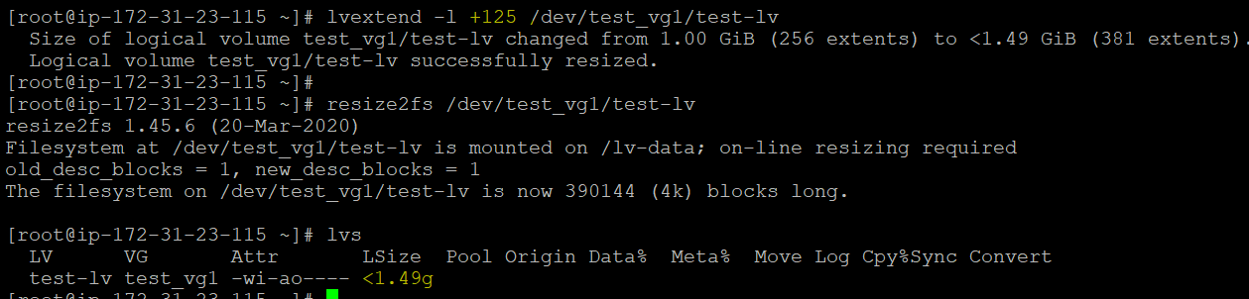

**Reducing Lvm**

df -h

umount /dev/test_vg1/test-lv

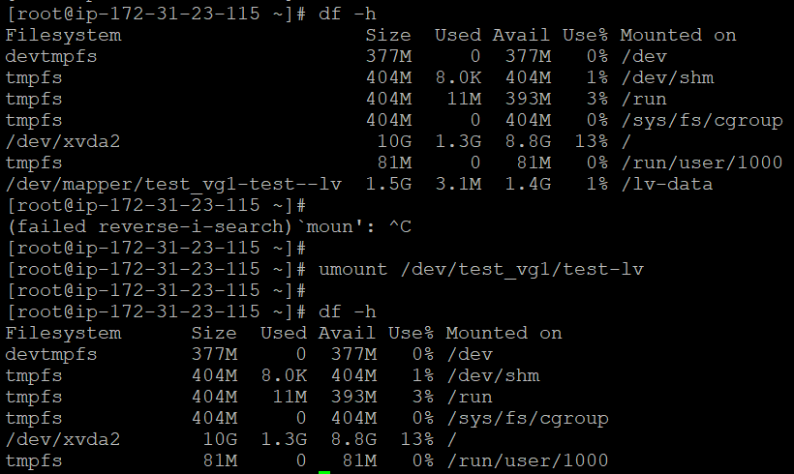

**check for the file-system error using e2fsck**

# e2fsck -ff /dev/test_vg1/test-lv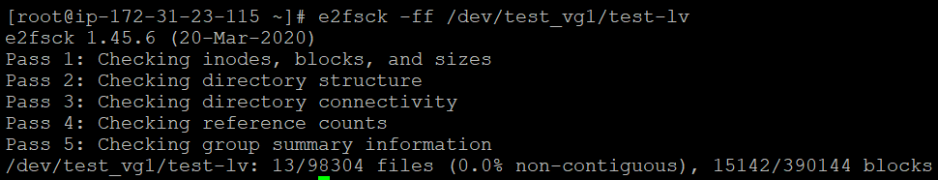

#lsblk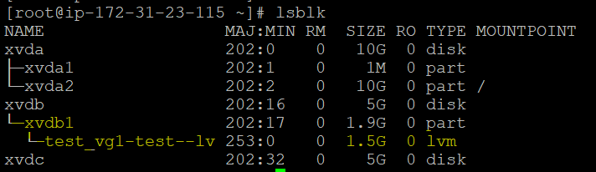

# lvreduce --resizefs -L -500M test_vg1/test-lv

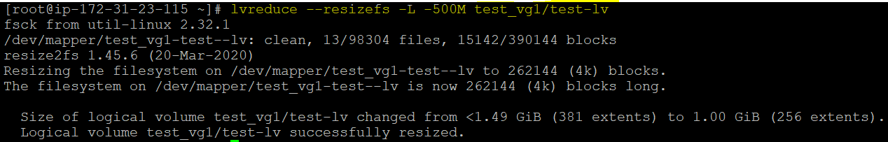

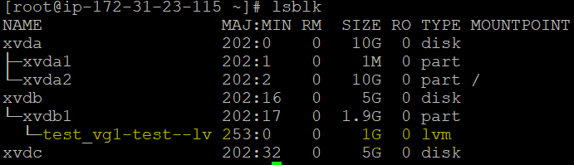

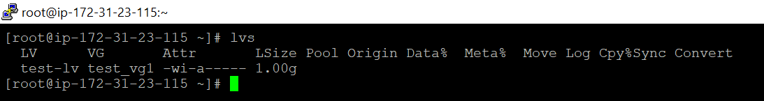

Once done the reduce mount the file system